Instructions for Workshop workflow:
- Login instructions
Once you set up Duo Push, you will be using either the terminal (for Mac users) or PuTTY (for Windows users):
Type the username we provided you with in slips and the password, case-sensitive:

Mac Users:
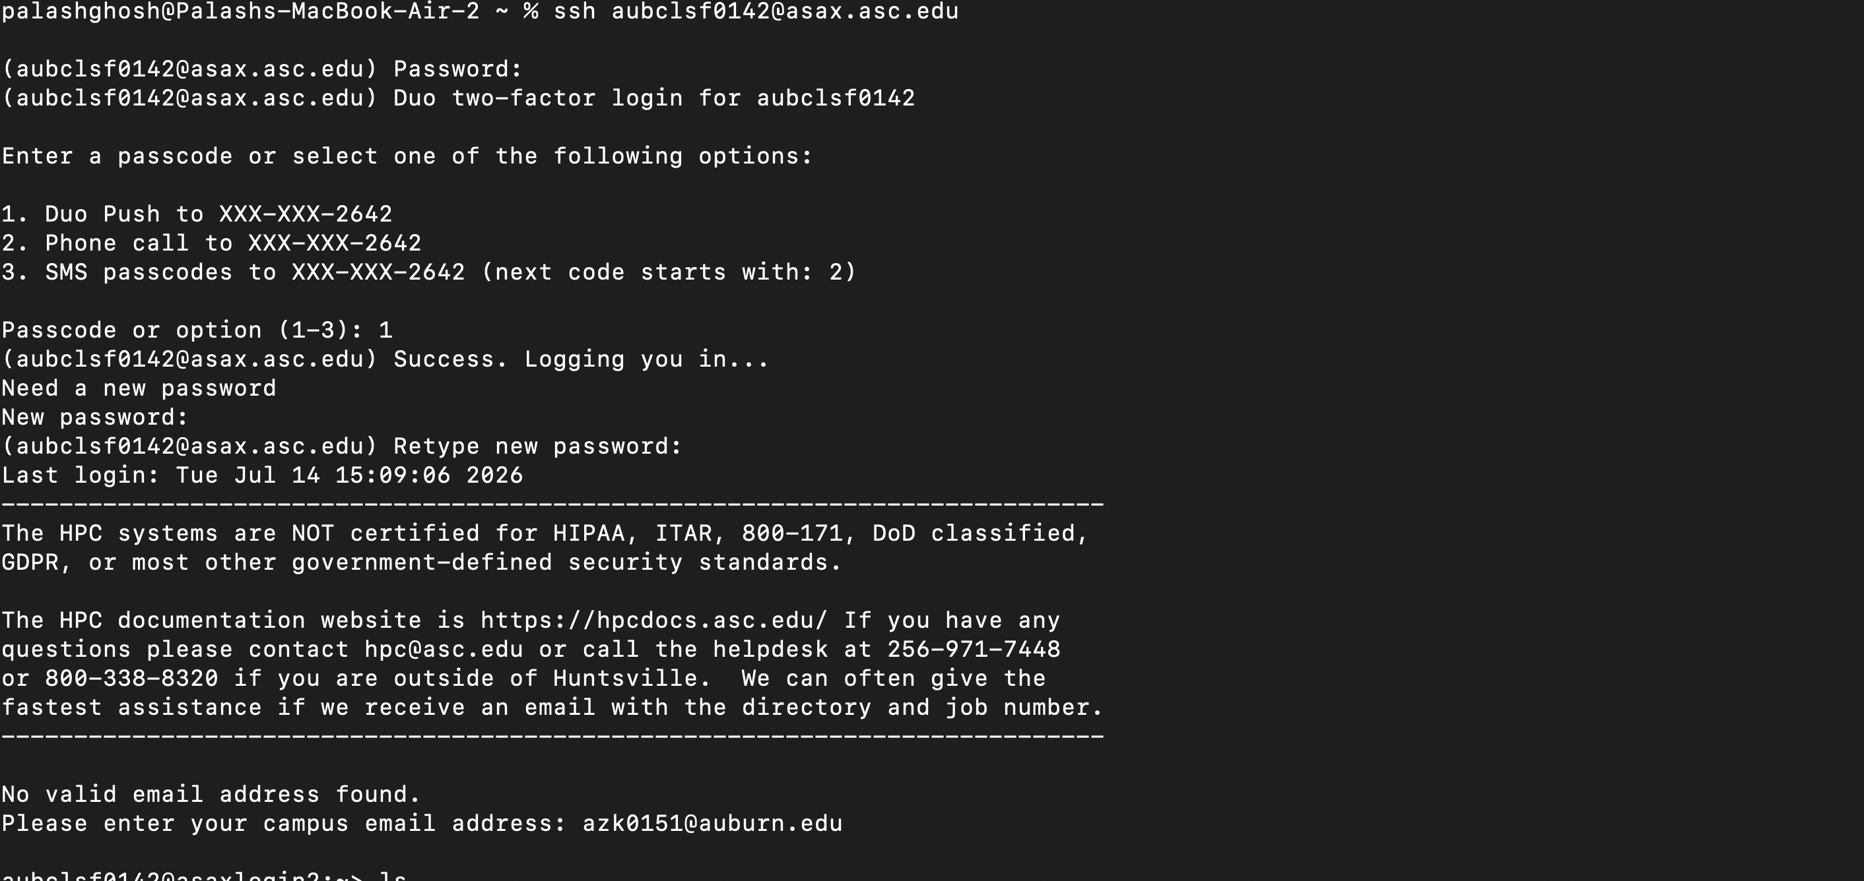
When it asks for the new password, please type case-sensitive: auburnuniversity
Windows Users:
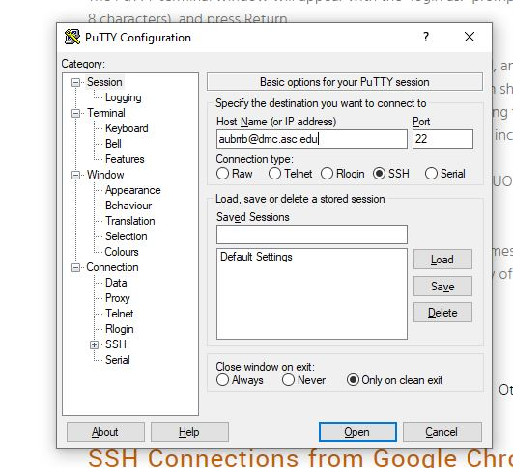
When it asks for the new password, please type case-sensitive: auburnuniversity

- Once you log in use the following commands:
PART 1A:
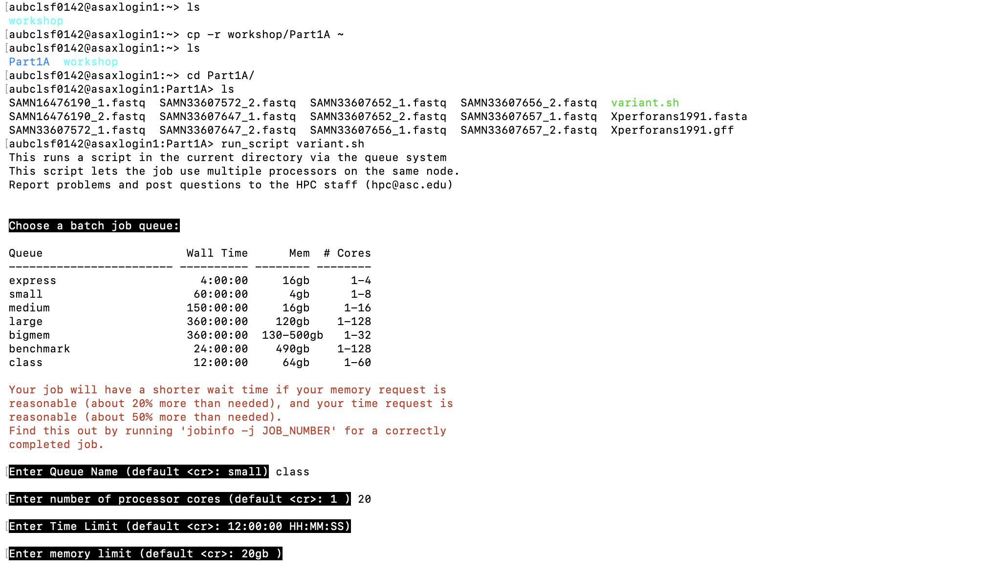
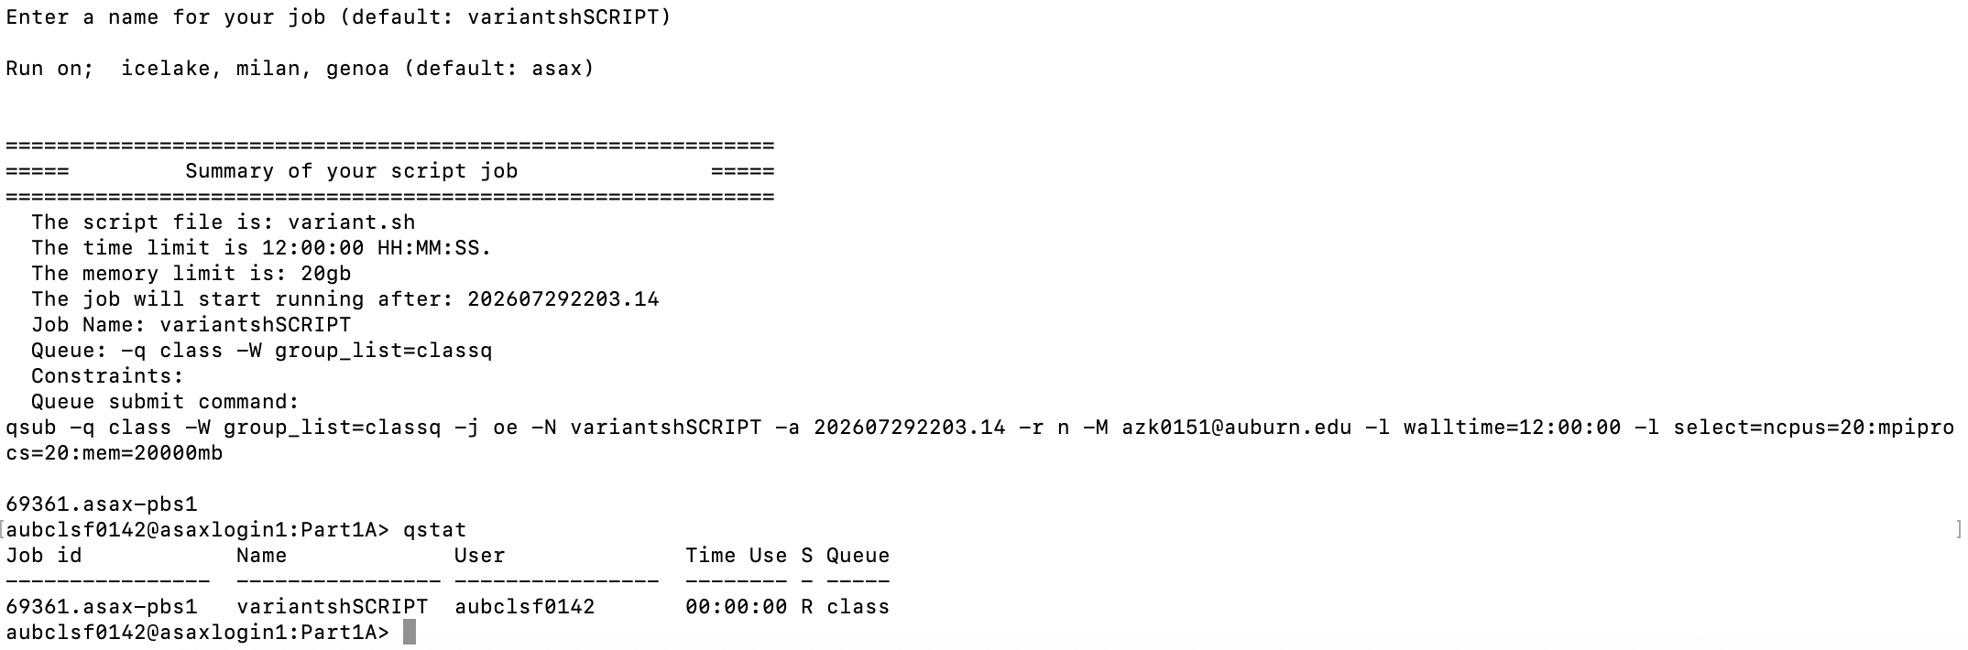

- Running this would take about 20 minutes; once it is done, Once you type “ls”, you will see the following files in your directory:
- And you can see the output here:
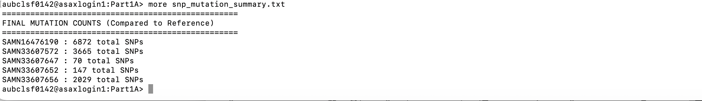
PART 1B
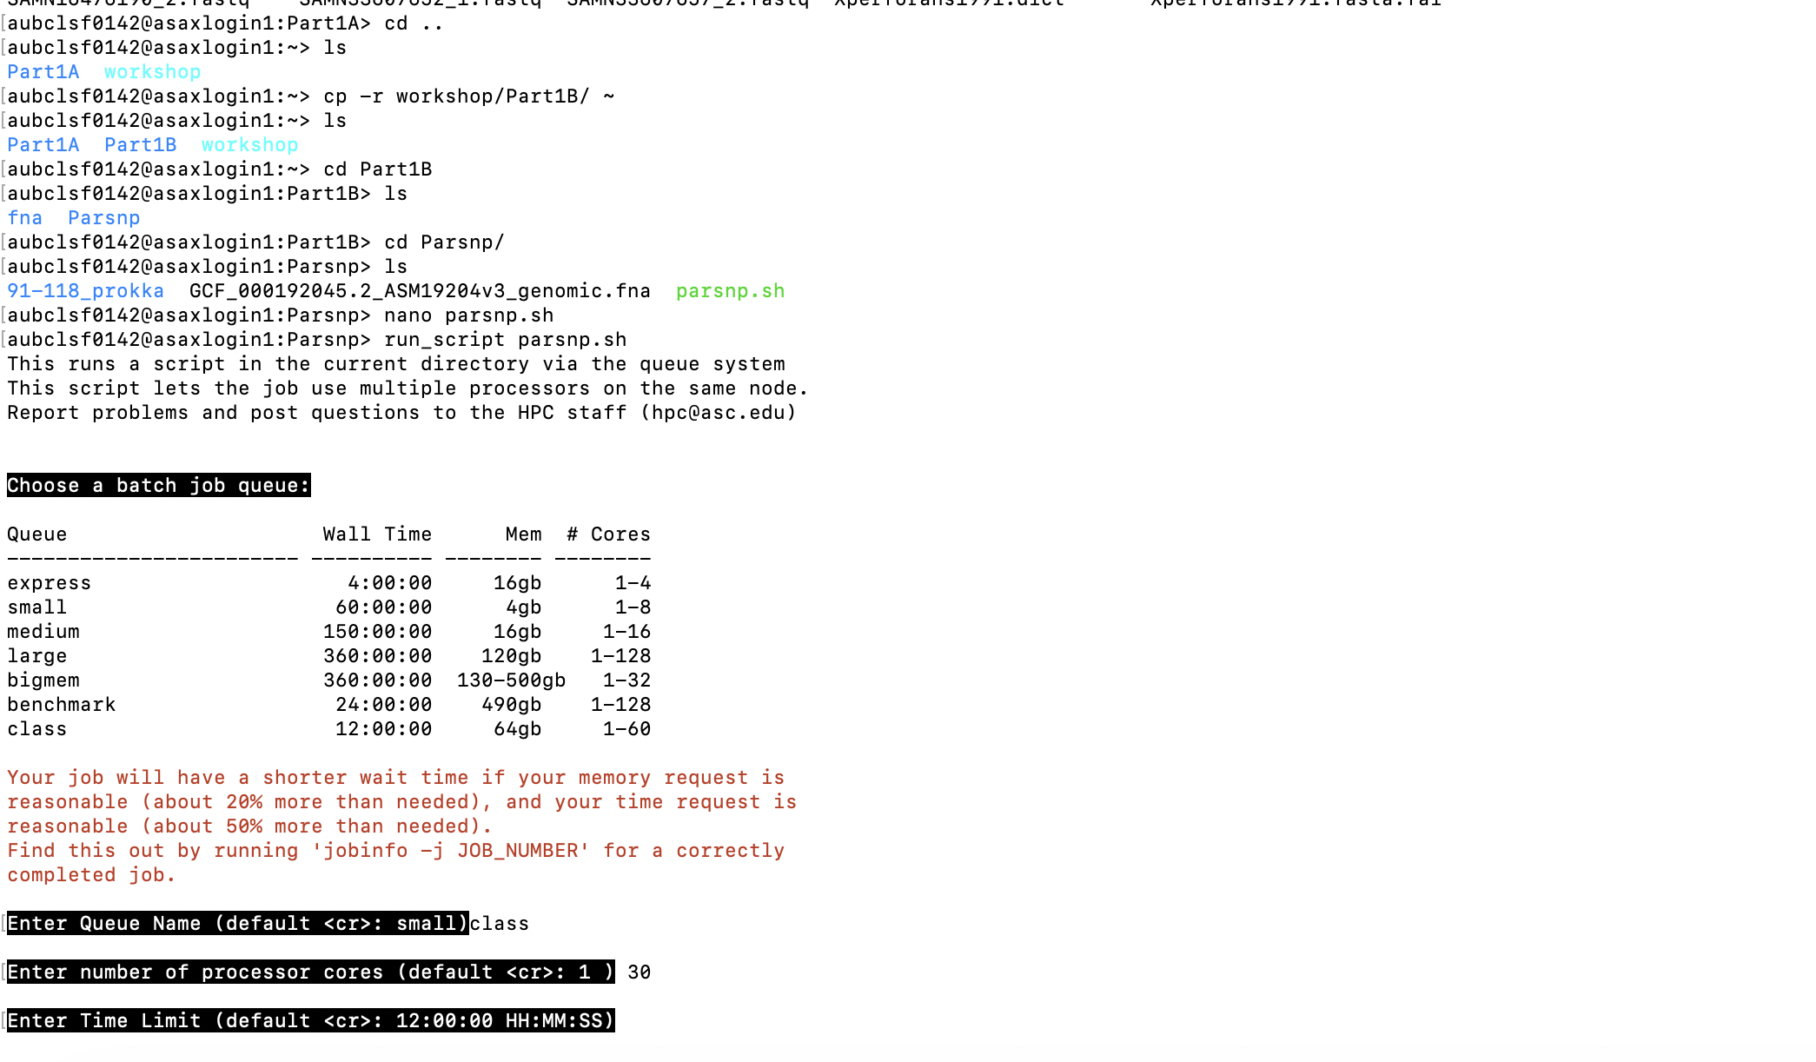
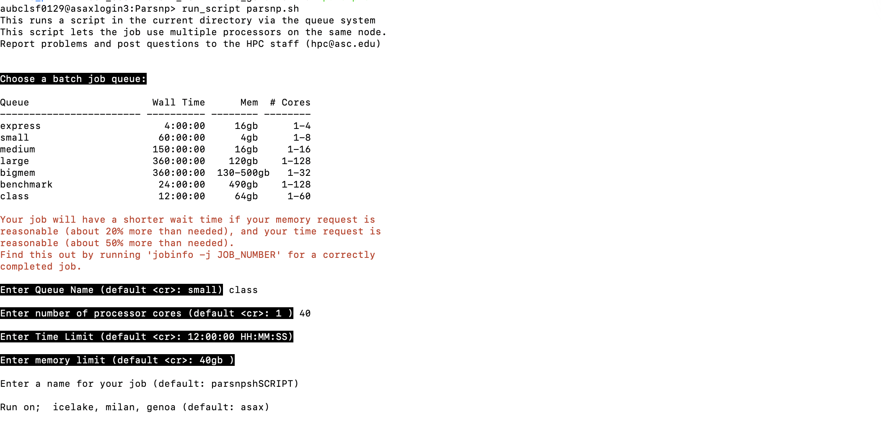
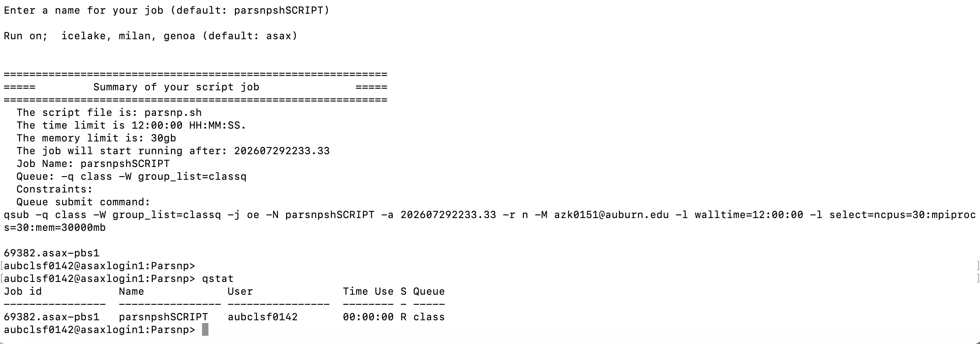
- This command takes about 1 hour, so we will run it at the beginning, just after Part 1A, so that it will run in the meantime.
- After we get the output, these are the files
- we will need the “Xp_hierbaps.csv” and “Rheirbaps_Xp.Rmd” files downloaded from the GitHub repository (https://github.com/Potnislab/APS-Plant-Health-Workshop-2026).

Part2
To run part2, we need to run the following commands:
For Inter-species diversity
Firstly, we will build a database and then quantify relative abundance.

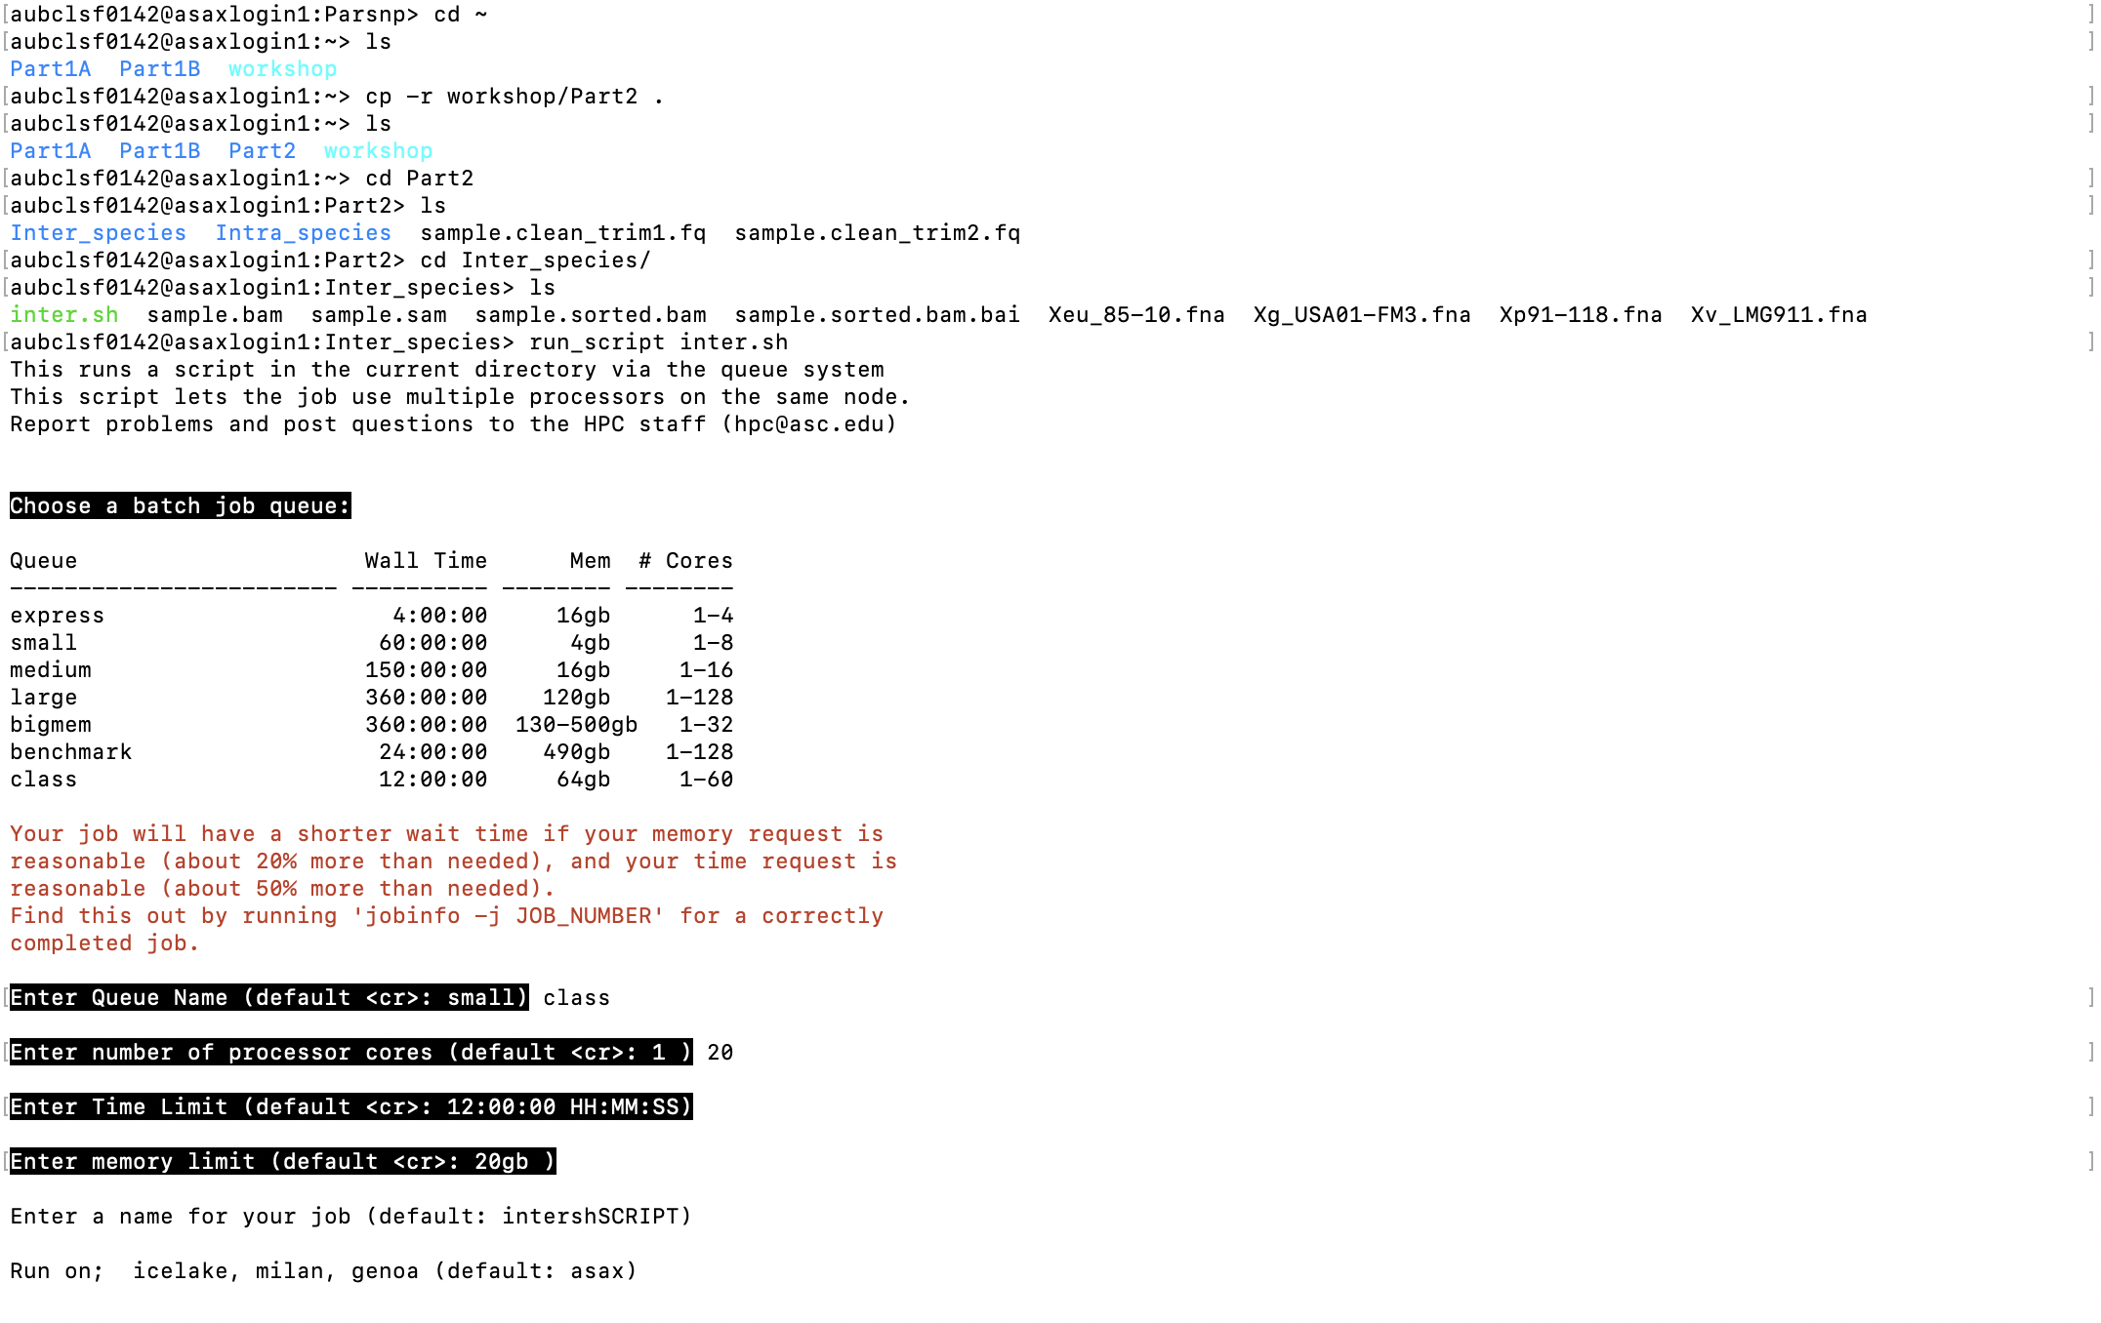

Below are different commands, we will run directly on console:

module load strainest
strainest mapgenomes Xp91-118.fna Xeu_85-10.fna Xg_USA01-FM3.fna Xv_LMG911.fna Xp91-118.fna MR.fna
strainest map2snp Xp91-118.fna MR.fna snp.dgrp

strainest snpdist snp.dgrp snp_dist.txt hist.pdf

strainest snpclust snp.dgrp snp_dist.txt snp_clust.dgrp clusters.txt

strainest mapgenomes Xp91-118.fna Xeu_85-10.fna Xg_USA01-FM3.fna Xv_LMG911.fna Xp91-118.fna MA.fna

We won’t be running this because it takes longer to run. So, we have provided you with the output file directly
#!/bin/bash
module load strainest
source /opt/asn/etc/asn-bash-profiles-special/modules.sh
module load bowtie2/2.5.1
module load samtools/1.11
bowtie2-build -f MA.fna MA
bowtie2 --very-fast --no-unal -x MA -1 ../sample.clean_trim1.fq -2 ../sample.clean_trim2.fq -S Sample.sam
samtools view -b Sample.sam > Sample.bam
samtools sort Sample.bam -o Sample.sorted.bam
samtools index Sample.sorted.bam
strainest est ./snp_clust.dgrp Sample.sorted.bam ./sample_Inter

The output file is already present in your folder named as “Sample_Inter”

For Intra-species diversity:
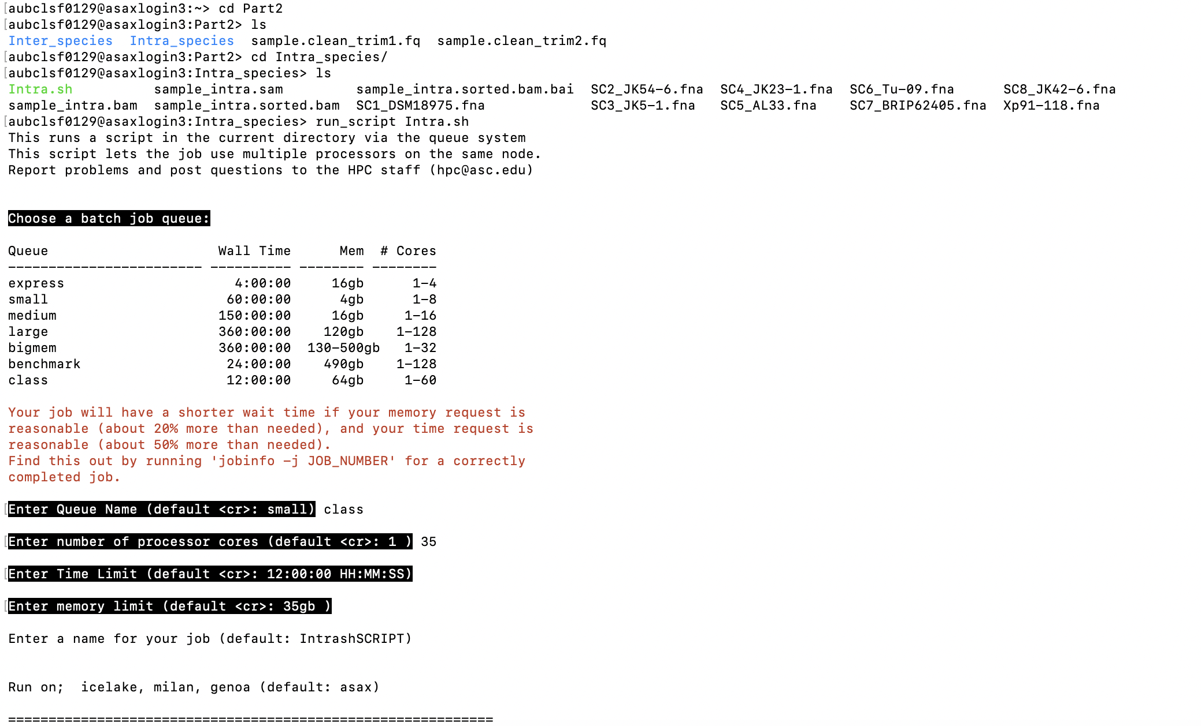

It takes about 15 min and we will see output file named as “Sample_Inter”

